Get start with Tableau:

# Basics of Reading Data:

## Understanding the Basic Concept:

### What is Data set?

In Tableau a data set is defined as a set of refined data which is used for analysis by building visualizations through graphs. It is obtained from different data sources and databases.

Every chart which is designed in Tableau is connected to a data set in-order to visualize the data.

### Data Sources

These are the other data sources that Tableau can connect and visualize.

<https://help.tableau.com/current/pro/desktop/en-us/exampleconnections_overview.htm>

### What happens when Tableau connects to a data set?

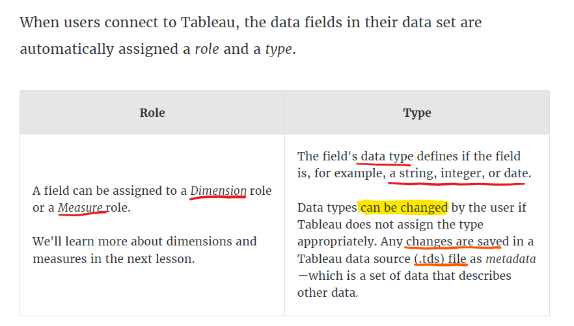

Changes made in Tableau do not affect the actual data source. It will be stored as metadata (.tds file) for the Tableau file.

### What is a field?

A column in excel sheet is field. It represents a particular set of data in the data set. It is a single piece of information from a record in a data set.

* Qualitative Fields – Dimensions – Blue – it is mapped to a limited value of data and it describes or categorize the data. Tells you What, when and who. Slices the quantitative data
* Quantitative Fields – Measures – Green – It is mapped to a huge range of data where numbers plays a major role in it. So it is a Numerical data. Provides the measurements for qualitative categories. Can be used in calculations.

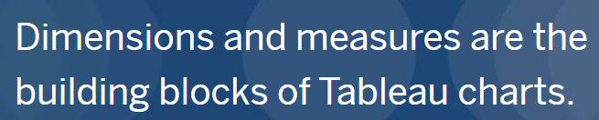

* The ‘Data pane’ shows the Dimensions and Measures of the datasets

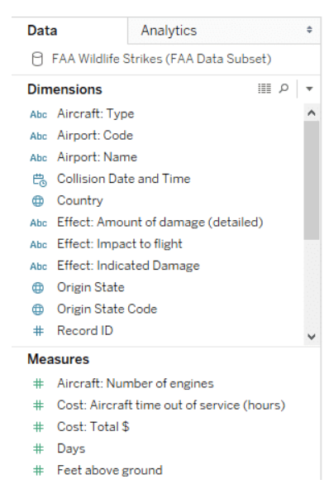

### How fields creates the Visualization?